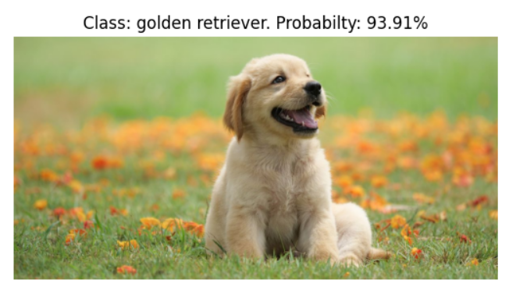

Resnet 50 dog id

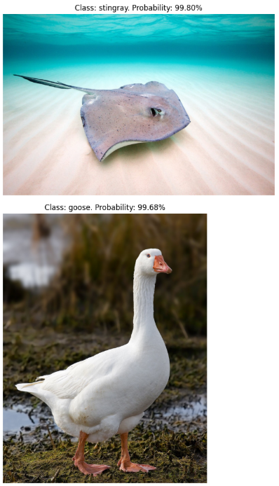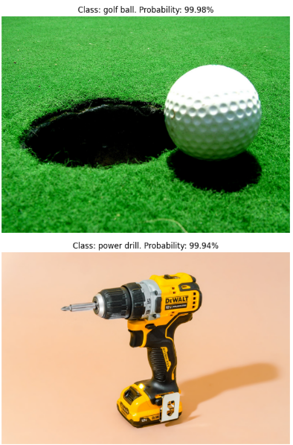

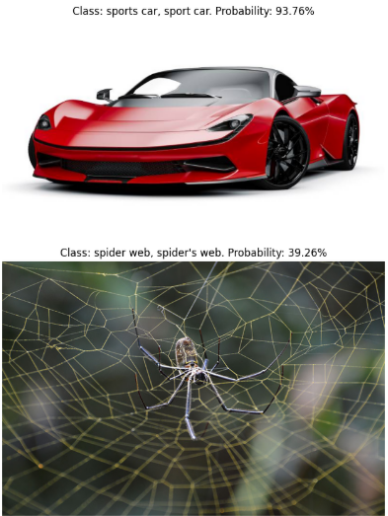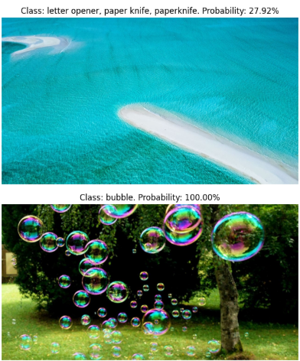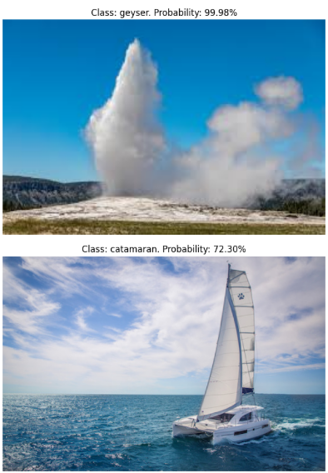

Resnet 50 ids

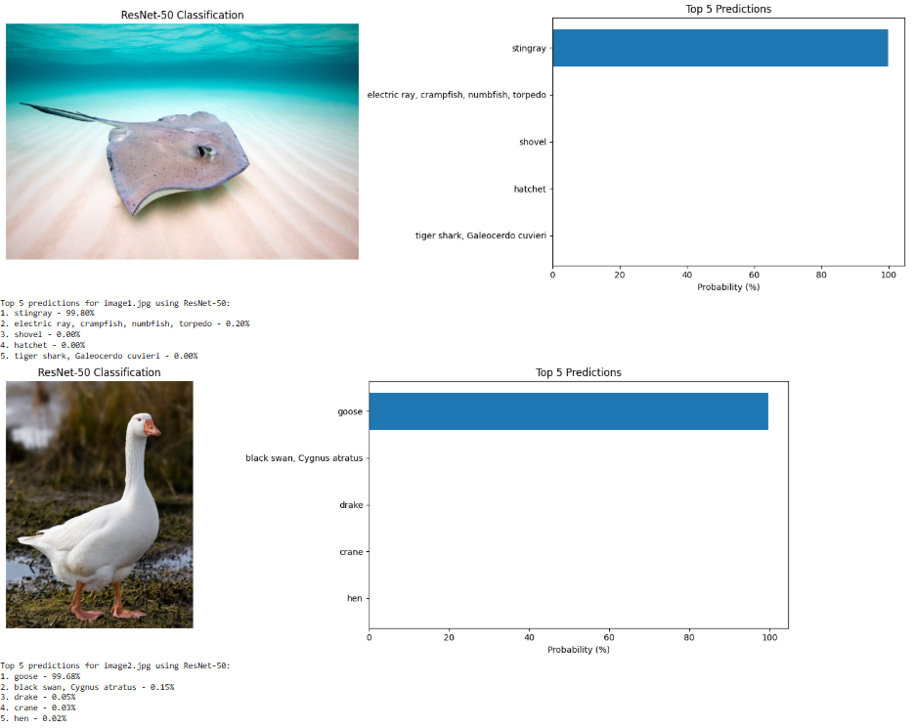

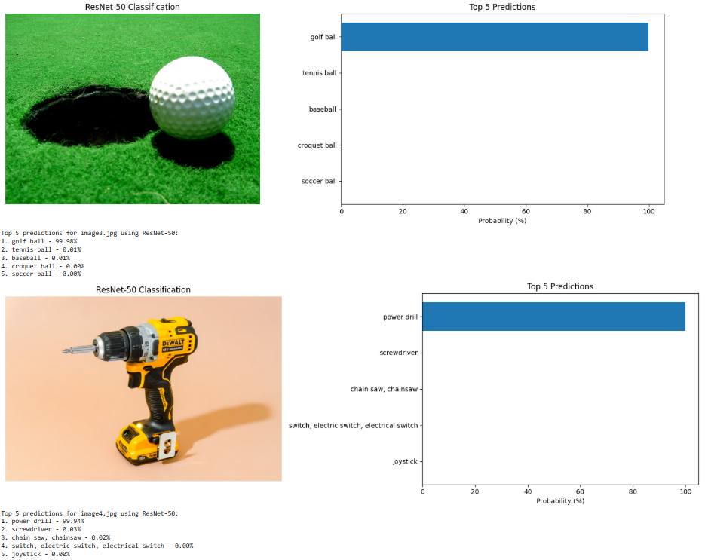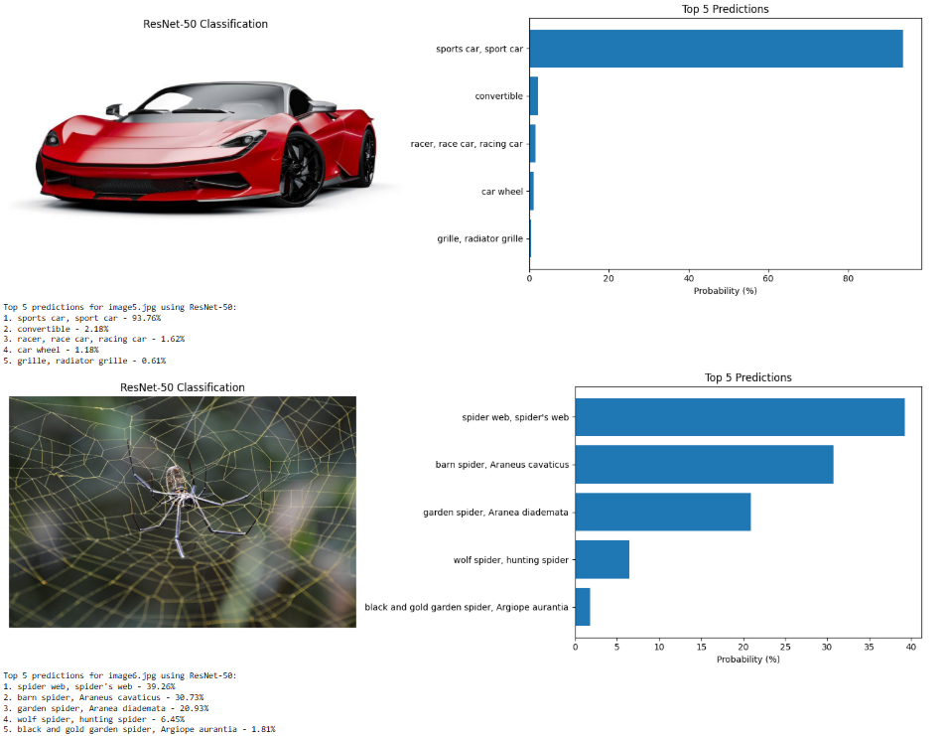

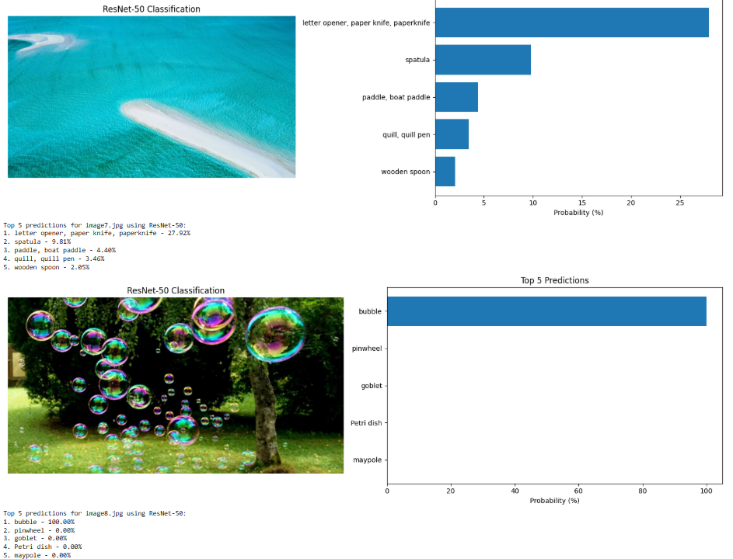

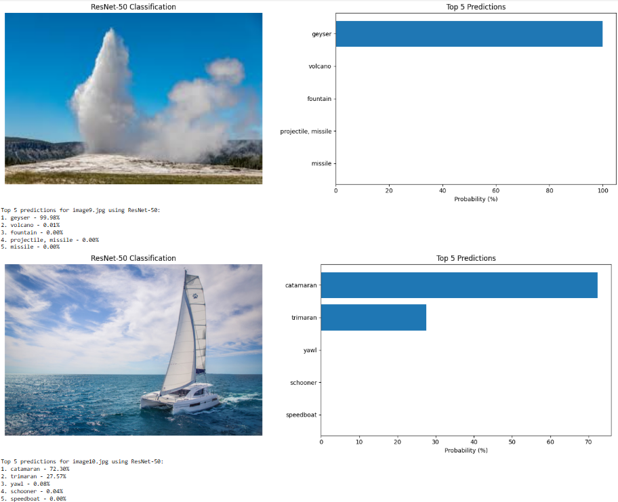

Resnet 50 predictions

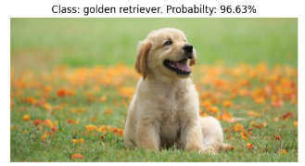

Resnet 101 dog

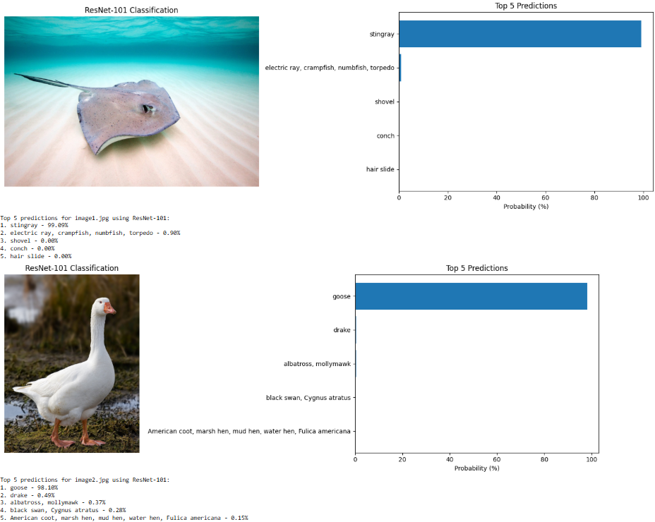

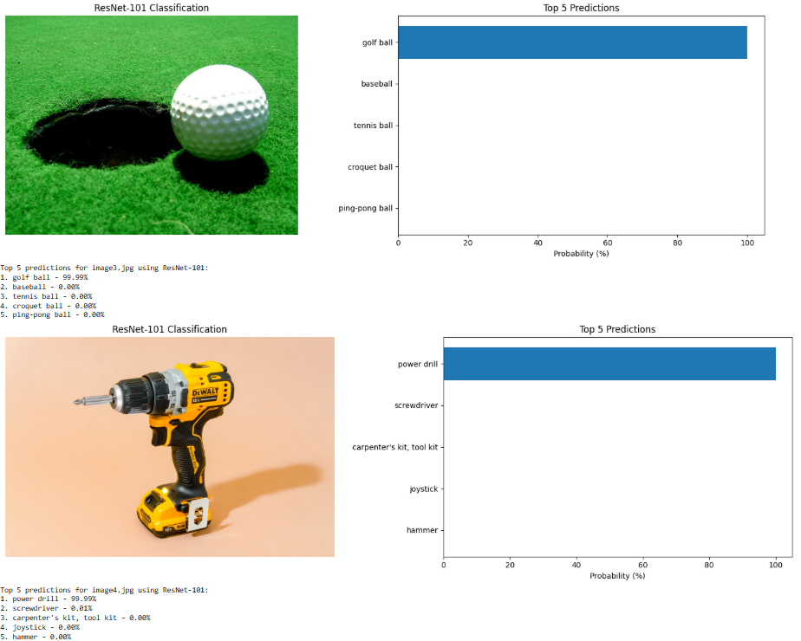

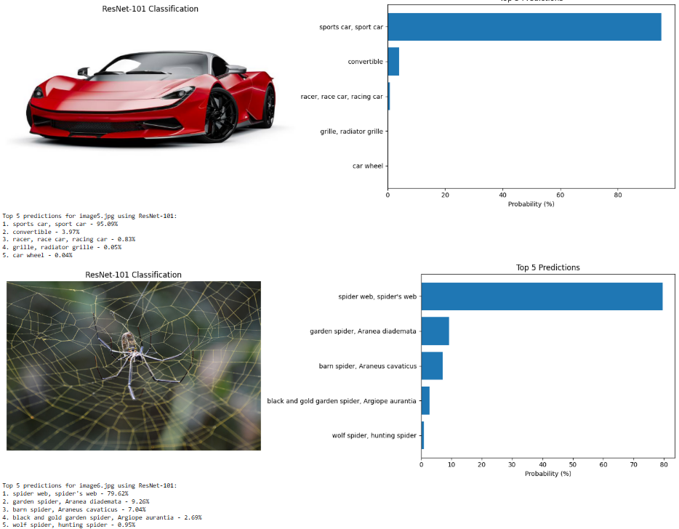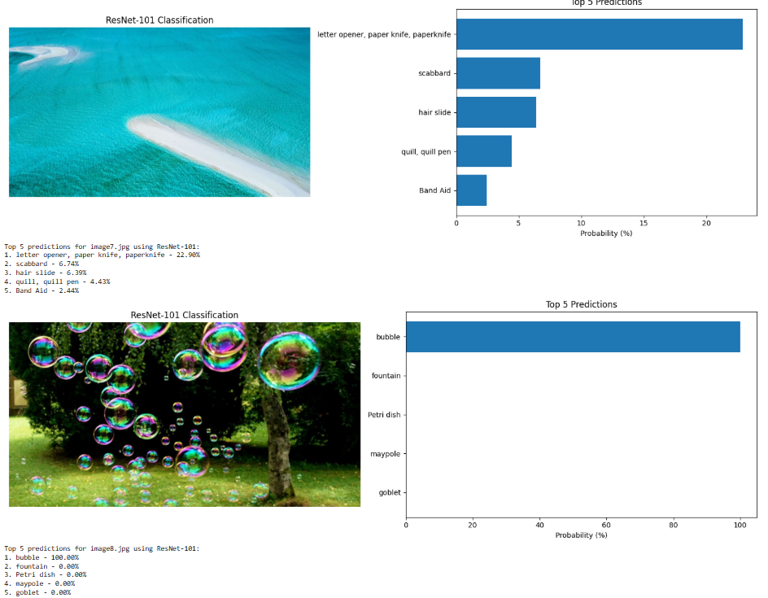

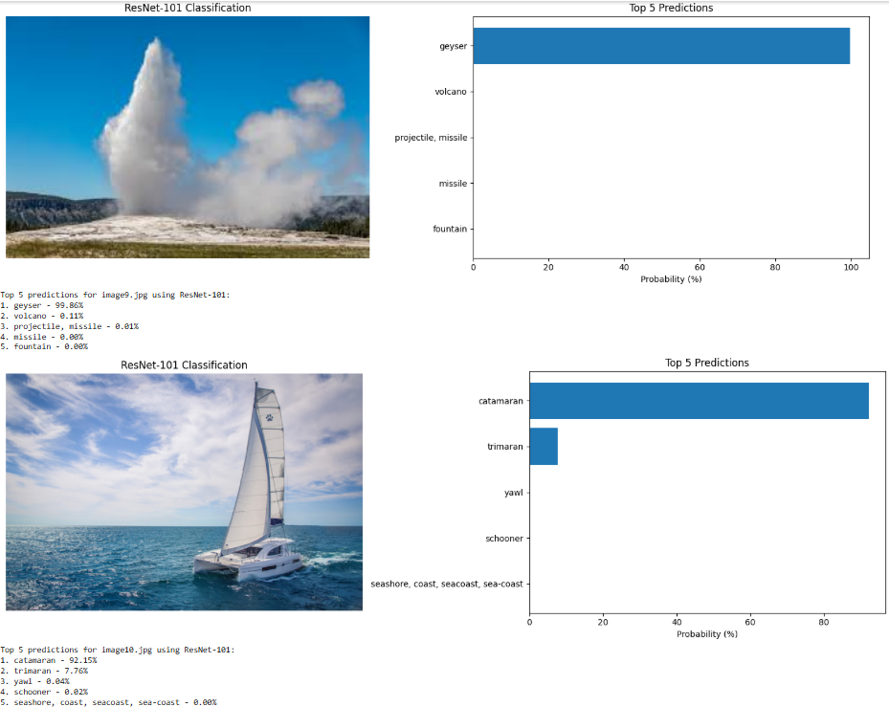

Resnet 101 predictions

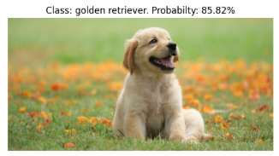

Densenet dog

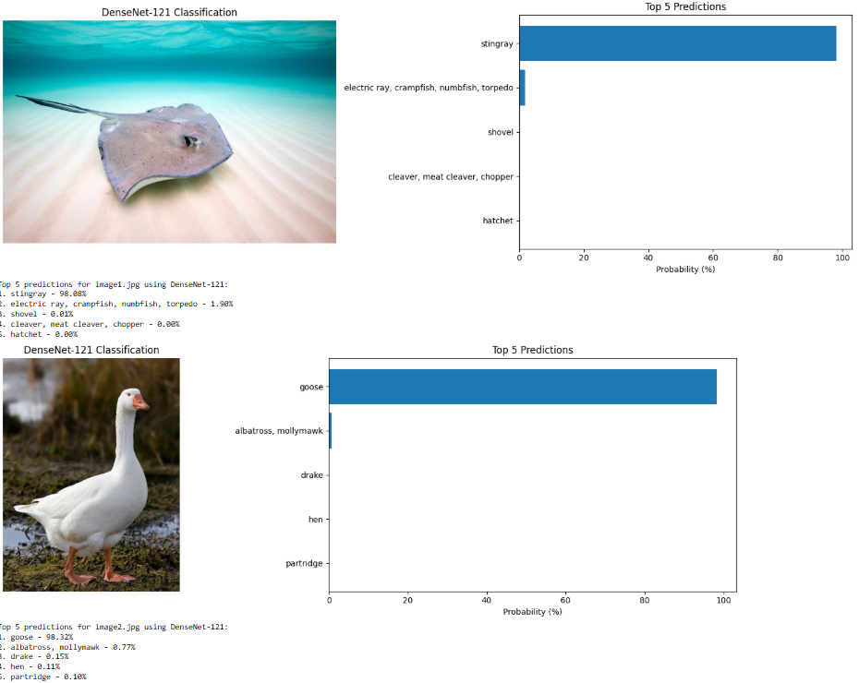

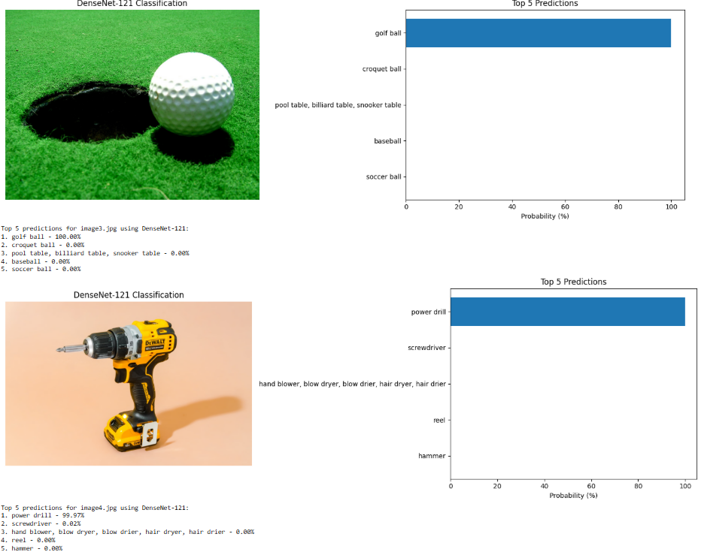

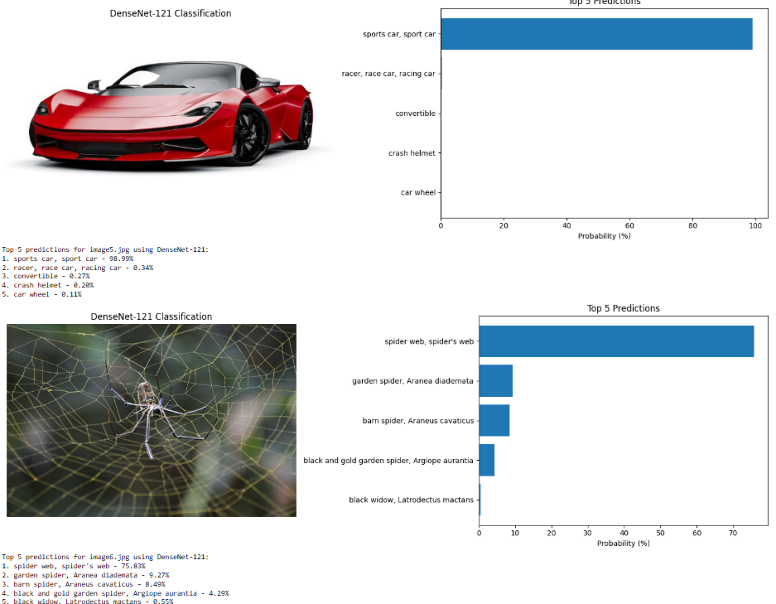

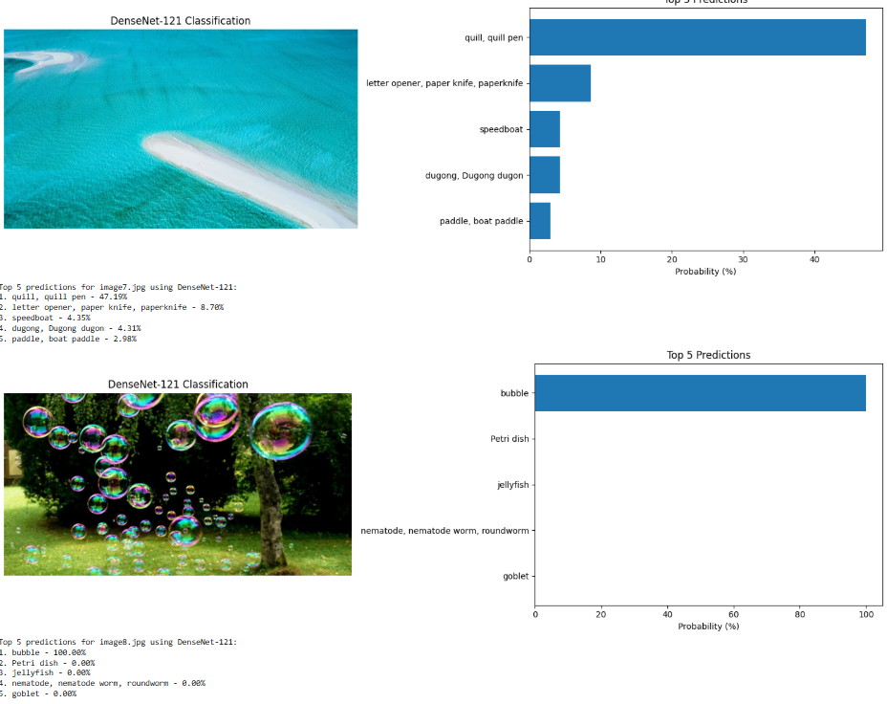

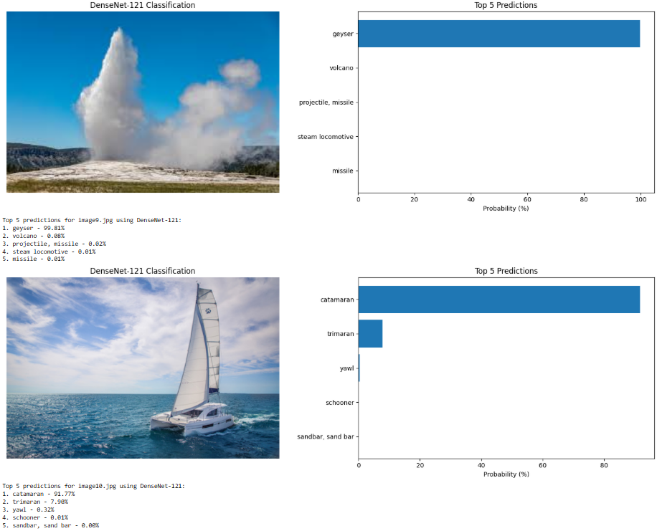

Densenet 121 predictions

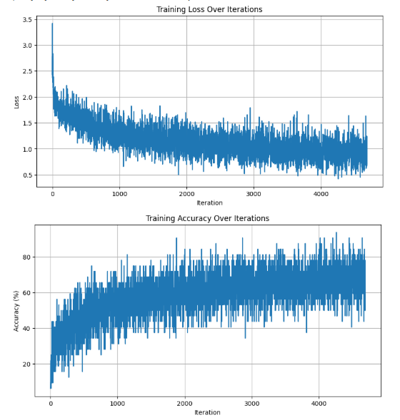

Q2 training results

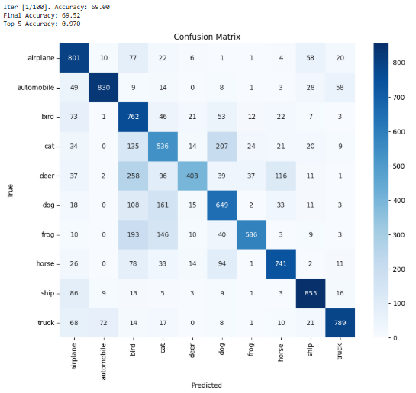

Q2 accuracy and confusion matrix

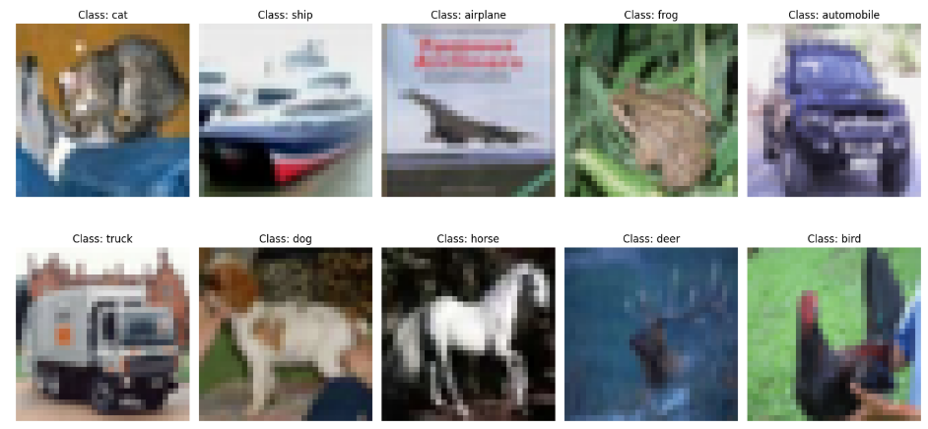

Q2 example images

Images from:

<https://marinesanctuary.org/blog/sea-wonder-southern-stingray/>

<https://en.wikipedia.org/wiki/Domestic_goose>

<https://en.wikipedia.org/wiki/Golf_ball>

<https://www.nytimes.com/wirecutter/reviews/the-best-drill-for-common-household-projects/>

<https://sapphireexecutivetravel.com/types-of-sport-car/>

<https://www.nhm.ac.uk/discover/what-are-spider-webs-made-of.html>

<https://www.americanoceans.org/facts/what-is-a-sandbar/>

<https://blog.indypl.org/kids/bubbles-surface-tension/>

<https://en.wikipedia.org/wiki/Geyser>

<https://www.discoverboating.com/buying/boat/catamarans>